**Secondary Storage**

* A storage medium that holds information until it is deleted or overwritten.
* This section of storage is also referred to as backup storage.
* The storage capacity of primary storage is not sufficient to store the large volume so secondary storage.
* The secondary memory is accessed indirectly via input/output operations.
* This memory is also called backup storage or mass storage media.

**Distinguishing Characteristics of Secondary Storage**

As we examine some secondary storage media, look out for the following:

* Capacity
* Access Speed
* Access Method
* Portability

**Types of Secondary Memory**

Secondary memory is of two types:

1. Fixed Storage
2. Removable Storage

* **Fixed Storage:**
* A fixed storage is an internal media device that is used to store data in a computer system.
* Generally, the data of the computer system is stored in a built-in fixed storage device.
* Following are Fixed Storage devices:

1. Internal Flash Memory
2. SSD (Solid-State Disk)
3. Hard Disk Drives (HDD)

* **Hard Disk Drives (HDD)**
* Hard Disk was introduced and patented in the year 1956 in IBM’s San Jose, California laboratory.
* It is a rigid magnetic disc that is used to store data.
* It is located within the drive unit.
* Hard disks or hard disk drives come in different storage capacities(like 256 GB, 500 GB, 1 TB, and 2 TB, etc.).

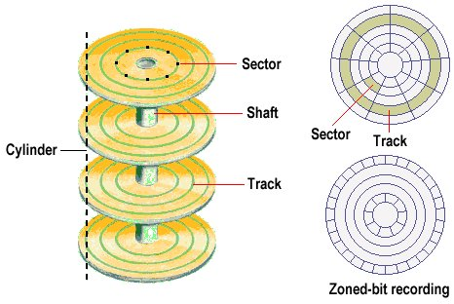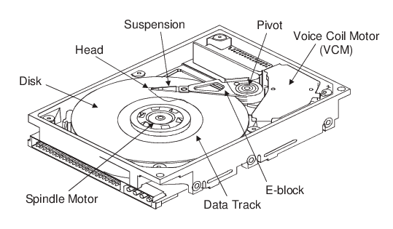

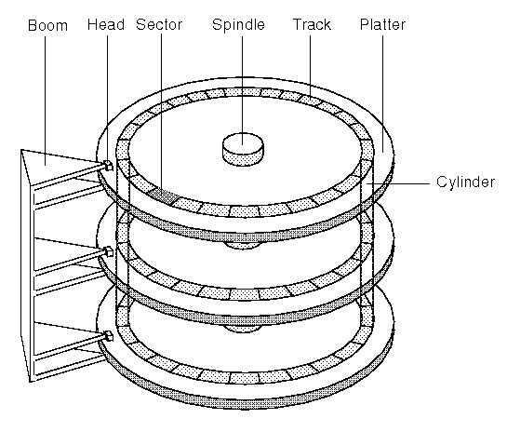

**Advantages of the Hard Disk:**

The advantages of a Hard Disk Drive are given as follows:

1. One of the significant advantages of a Hard Disk drive is that its cost is low.
2. Another advantage of a Hard Disk is that it is readily available in the market.
3. Hard Disk is faster than optical disks.
4. The capacity for storing the data in HDDs is large.

**Disadvantages of the Hard Disk:**

The disadvantages or limitations of Hard Disk Drive are given as follows:

1. The speed of reading and writing in HDD is slower than the RAM.
2. HDDs are noisy.
3. Another disadvantage of HDD is energy inefficiency.
4. HDDs consume more power.
5. The form factor of HDDs is heavier than the SSDs.

* **Solid-State Drive: (SDD)**
* SSD (Solid State Drive) is also a non-volatile storage medium that is used to hold and access data.
* Solid-state drive (SSD) is a solid-state storage device that uses integrated circuit assemblies as memory to store data.
* It is more expensive.
* These storage devices store the data in the semiconductor cells.

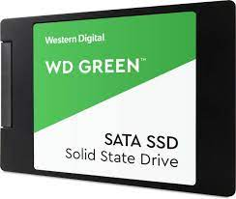 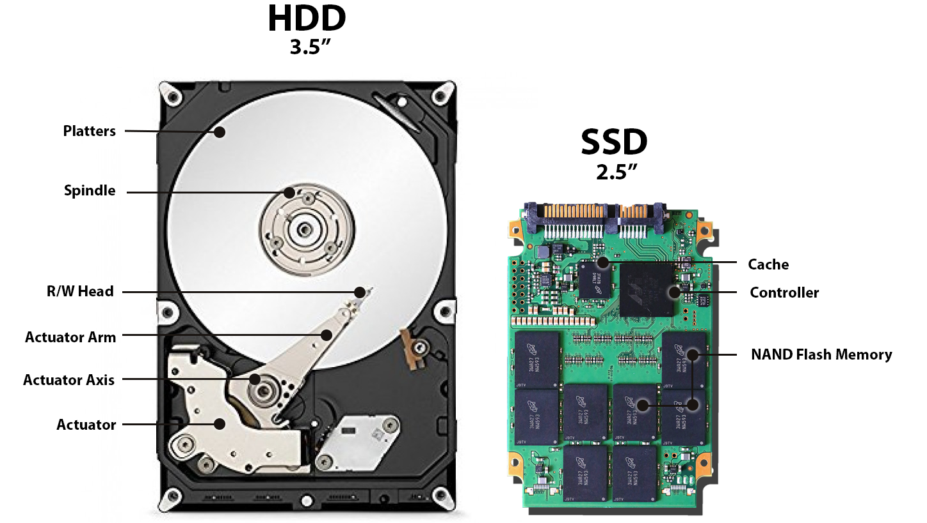

* **Removable Storage:**
* In secondary memory, removable storage is an external media device that is used to store data in a computer system.
* It is a storage device that can be inserted or removed from the computer according to our requirements.
* Following are Removable Storage devices:

1. Optical discs (like CDs, DVDs, Blu-ray discs, etc.)
2. Memory cards
3. Floppy disks
4. Magnetic tapes
5. Disk packs
6. Paper storage (like punched tapes, punched cards, etc.)